
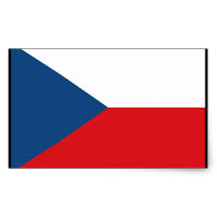

The Czech- Tanzania Business Forum on 2nd Mei, 2017.
REGISTRATION INFORMATION

For participation, please fill in the attached registration form and send to
lattifa.kigoda@tic.co.tz or ayoub.magarya@tic.co.tz

FULL NAME: LEONARD MANGU JOSEPH
DESIGNATION/ TITLE: CHIEF EXECUTIVE OFFICER
PASSPORT NO: AB669698

RELIABLE CONTACTS IN TANZANIA:
FIRM/ COMPANY: PHRONETEC COMPANY LIMITED

P.O. Box ; 2865,DAR ES SALAAM

LOCATION: DAR ES SALAAM.

PHONE (Office): +255 768457571

PHONE (Mobile): +255 659501640

FAX No : NIL

E-MAIL : leon@phronetech.com
WEBSITE: www.phronetech.com

YOUR CURRENT COMPANY’S BUSINESS ACTIVITIES:
- EDUCATION DIGITIZATION PLATFORM FOR HIGHER LEARNING INSTITUTIONS(OSIM).
- JOB OPPORTUNITIES ADVERTISEMENT THROUGH THE PLATFORM.
- BIG DATA ANALYTICS ON PLATFORM DATA AND MOBILE APPLICATION FOR THE PLATFORM.
AREAS OF INTEREST WITH CZECH CONTERPARTS:
- TECHNOLOGY TRANSFER
- PARTNERSHIP WITH CZECH COUNTERPARTS
- VENTURE CAPITALISTS INVESTMENT FROM CZECH COUNTERPARTS

KARIBUNI SANA

